Water quality monitoring - KEY
Water is not only necesarry for human life, it is also the home of countless other species. Water has many physical, chemical and biological characteristics, and these differ for each type of water. For example, the amount of dissolved oxygen, phosphate, nitrate, nitrite, or water hardness, pH level (acidic – alkaline) determines water quality, and it can be defined by a range of variables which limit water use. Natural waters in many properties differ from drinking water.
Activity
Can you use the tools of a scientist?
Procedure
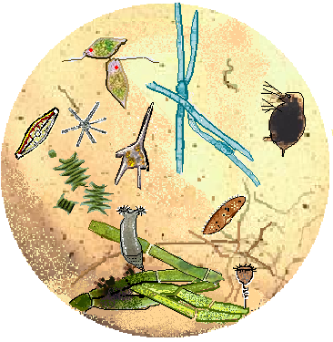
1, There are three water samples: from lake Balaton, Canal water and drinking water. Observe the water under the microscope, turn the fine adjustment for clear focus. Describe what you observe in the water!
rotatory (ciliated worm)
blue-green algae (cyanophyta)
flagellate algae (euglenophyta)
green algae (chlorophyta)
ciliata (protozoa- paramecium)
diatom algae
bacterium
water flea (microscopic crabs - daphnia)

organic debris
Dinoflagellate algae (Ceratium hirundinella)

observations: blue-green algae, microscopic crabs, green algae, organic debris dinoflagellate algae
2, Notice the water samples with transmitted and reflected light! What is the difference? Are there any floating sediments?
Samples with transmitted light gave a 2D picture, while samples with reflected light a 3D picture. Tgere were floating sediments and they were seen in 2D.
3, Examine the quality of the water! Measure the pH, the amount of dissolved phosphate! It helps in testing instruction manual of the water quality package. What is the difference? Explain the differences!
 | water sample from lake Balaton | Canal water | drinking water
pH | around 8 pH | 9pH | 7pH
dissolved phosphate | 0,2 – 0,3 | 0,6 – 0,7 | 0 and + Cl (chlorine)

Explain the differences!
Drinking water is purified so the dissolved phosphate is removed and neutralized. But the water from the lake Balaton and the canal water are natural waters.

Water purification
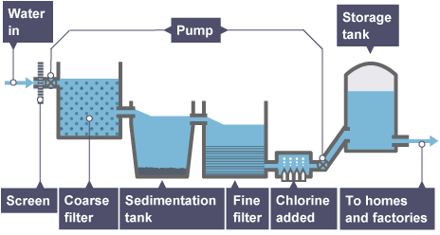
Tap water (drinking water) of city Fonyód is a purified water of lake Balaton and karst water. The waters disinfection are carried out by chlorination. Let's show the chlorine in the drinking water!

4, Dropping silver-nitrate solution into the drinking water in a test tube! What are you experiencing?
Watch the color of precipitate! The colour is white because there is Cl ( chlorine)
5, Put small pieces of soap (or liquid soap) in the water samples! What can you see? What is the reason?
(Foam or no foam the soap in hard water?)
There is no foam, because Cl reduces it
6, What can be used for drinking water? Examine the apple juice, lemonade, etc.! Show off glucose from drinks with Fehling's reaction! Pour a little Fehling I and Fehling II reagents into the drinks! Watch the colour of precipitate! Put the test tube in warm water or heat the solution if necessary! What can you see? What is the reason?
apple juice lemonade with glucose with sucrose
Pour a little Fehling I and Fehling II reagents into the drinks

What can you see? What is the reason?
We could see at first blue, green then yellow and orange colours. The colours were changing. We detected sugar.

