# **Water quality monitoring**

Water is not only a necessary for human life, it is also the home of countless other species. Water has many physical, chemical and biological characteristics, and these differ for each type of water. For example, the amount of dissolved oxygen, phosphate, nitrate, nitrite, or water hardness, pH level (acidic – alkaline) determines water quality, and it can be defined by a range of variables which limit water use. The natural waters in many property differ from the drinking water.

**Activity**

*Can you use the tools of a scientist?*

**Procedure**

1, Notice the poppy seeds with transmitted and reflected light! What is the difference?

…………………………………………………………………………………………………………………………………………………………….

…………………………………………………………………………………………………………………………………………………………….

2, **There are some water samples: from lake Balaton, Canal water and drinking water.** Observe the water under the microscope, turn the fine adjustment for clear focus. Describe what you observe in the water! Are there any floating sediments?

rotatory (ciliated worm)

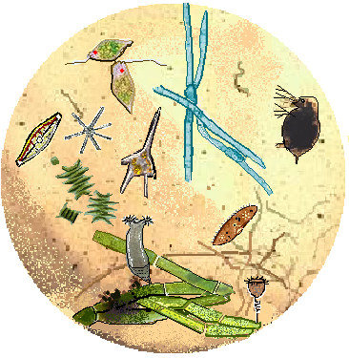

blue-green algae (cyanophyta)

flagellate algae (euglenophyta)

green algae (chlorophyta)

ciliata (protozoa- paramecium)

diatom algae

bacterium

water flea (microscopic crabs - daphnia)

organic debris

Dinoflagellate algae (Ceratium hirundinella)

observations: …………………………………………………………………………………………………………………………………………………………….

…………………………………………………………………………………………………………………………………………………………….

3, Examine the quality of the water! Measure the amount of dissolved phosphate (ortophosphate), nitrate, nitrite! It helps in testing instruction manual of the water quality package. What is the difference? Explain the differences!

|  |  |  |  |
| --- | --- | --- | --- |
|  | **water sample from lake Balaton** | **Canal water** | **drinking water** |
| **dissolved phosphate** | **few** | **little much** | no |
| **nitrate** | **few** | **little much** | no |
| **nitrite** | **few** | **little much** | no |

…………………………………………………………………………………………………………………………………………………………….

…………………………………………………………………………………………………………………………………………………………….

**Water purification**

**Tap water (drinking water) of city Fonyód is a purified water of lake Balaton and karst water. The waters disinfection are carried out by chlorination. Let's show the chlorine in the drinking water!**

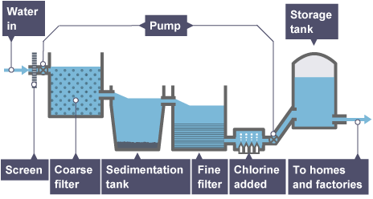

4, Put silver-nitrate solution into the drinking water in a test tube! What are you experiencing?

ch the color of precipitate!.............................................................................................................................

……………………………………………………………………………………………………………………………………………..................