Workshop: Science lab
During the workshop, we explored water from three scientific perspectives:
Physics: Investigating water's physical properties under various conditions (e.g.: water samples with transmitted and reflected light).
Chemistry: Comparing water from different sources (Lake Balaton, drinking water, canal water) to detect differences.
Biology: Studying the species dependent on water. (Observation under microscope)
Water quality monitoring
Water is not only a necesarry for human life, it is also the home of countless other species. Water has many physical, chemical and biological characteristics, and these differ for each type of water. For example, the amount of dissolved oxygen, phosphate, nitrate, nitrite, or water hardness, pH level (acidic – alkaline) determines water quality, and it can be defined by a range of variables which limit water use. The natural waters in many property differ from the drinking water.
Activity
Can you use the tools of a scientist?
Procedure
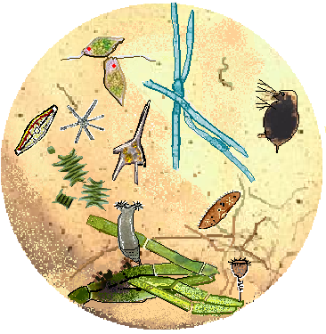
1, There are three water samples: from lake Balaton, Canal water and drinking water. Observe the water under the microscope, turn the fine adjustment for clear focus. Describe what you observe in the water!
rotatory (ciliated worm)
blue-green algae (cyanophyta)
flagellate algae (euglenophyta)
green algae (chlorophyta)
ciliata (protozoa- paramecium)
diatom algae
bacterium
water flea (microscopic crabs - daphnia)

organic debris
Dinoflagellate algae (Ceratium hirundinella)

observations: …………………………………………………………………………………………………………………………………………………………….
2, Notice the water samples with transmitted and reflected light! What is the difference? Are there any floating sediments?
…………………………………………………………………………………………………………………………………………………………….
3, Examine the quality of the water! Measure the pH, the amount of dissolved phosphate! It helps in testing instruction manual of the water quality package. What is the difference? Explain the differences!
 | water sample from lake Balaton | Canal water | drinking water
pH
dissolved phosphate

Explain the differences!
…………………………………………………………………………………………………………………………………………………………….
Water purification
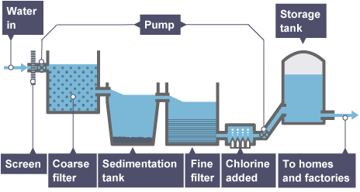
Tap water (drinking water) of city Fonyód is a purified water of lake Balaton and karst water. The waters disinfection are carried out by chlorination. Let's show the chlorine in the drinking water!

4, Dropping silver-nitrate solution into the drinking water in a test tube! What are you experiencing?
Watch the color of precipitate!...............................................................................................................
5, Put small pieces of soap (or liquid soap) in the water samples! What can you see? What is the reason?
(Foam or no foam the soap in hard water?)
……………………………………………………………………………………………………………………………………………………………………
6, What can be used for drinking water? Examine the apple juice, lemonade, etc.! Show off glucose from drinks with Fehling's reaction! Pour a little Fehling I and Fehling II reagents into the drinks! Watch the color of precipitate! Put the test tube in warm water or heat the solution, if necessary! What can you see? What is the reason?
apple juice lemonade with glucose with sucrose
Pour a little Fehling I and Fehling II reagents into the drinks

What can you see? What is the reason?
…………………………………………………………………………………………………………………………………………………………………………………………………………………………………………………………………………………………………………………………………………

