Exercise 1. Reading Comprehension
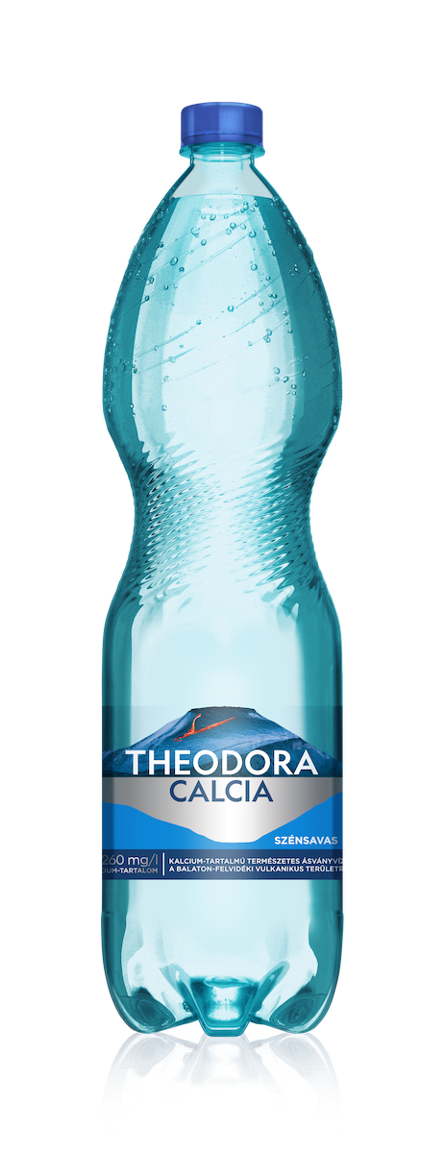
1. Which is one of the oldest and most famous mineral water factories in Hungary?

2. Where is the factory located and what is the name of the brand?

3. When did bottling begin and what was the first name under which the water was marketed?

4. What minerals is Kékkút water rich in?

5. When was the “Theodora” brand name introduced?

6. What happened to the company in the mid-20th century?

7. What developments were implemented between 2017 and 2018?

8. What does the factory do to preserve the natural purity of the water?

Exercise 2. Fill in the gaps
Words to use:
Kékkút – 1907 – Theodora – Lake Balaton – mineral – 2017 – Szentkirályi – natural springs
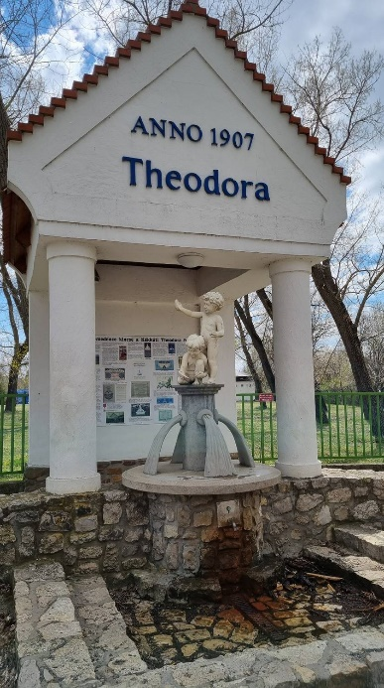
1. The factory is located in the village of __________, near __________
2. The water comes from deep __________.
3. The first commercial bottling began around the year __________.
4. The brand name __________ was introduced in 1921.
5. The company produces __________ water.
6. In __________, a syrup-mixing plant was opened to produce flavored water.

Answers:

Exercise 1.
1. One of the oldest and most famous mineral water factories in Hungary is Kékkúti Ásványvíz Zrt.
2.The factory is located in the village of Kékkút, in the Balaton Uplands, and the brand name is Theodora.
3.Bottling began in 1907, and the water was first marketed under the name "Kékkúti Anna-Source Water"
4. Kékkút water is rich in calcium, magnesium, and hydrogen carbonate.
5.The “Theodora” brand name was introduced in 1921.
6.In 1947, after World War II, the company was nationalized and became state-owned.
7. In 2017, a syrup-mixing plant was opened. In 2018, a new production hall and bottling line were opened.
8. The springs are located in a protected natural area .

Exercise 2.
1.Kékkút, Lake Balaton
2.natural springs
3.1907
4.Theodora
5.mineral
6.2017

